
Kamoinge’s Half-Century of African-American Photography
By Maurice Berger January 7, 2016

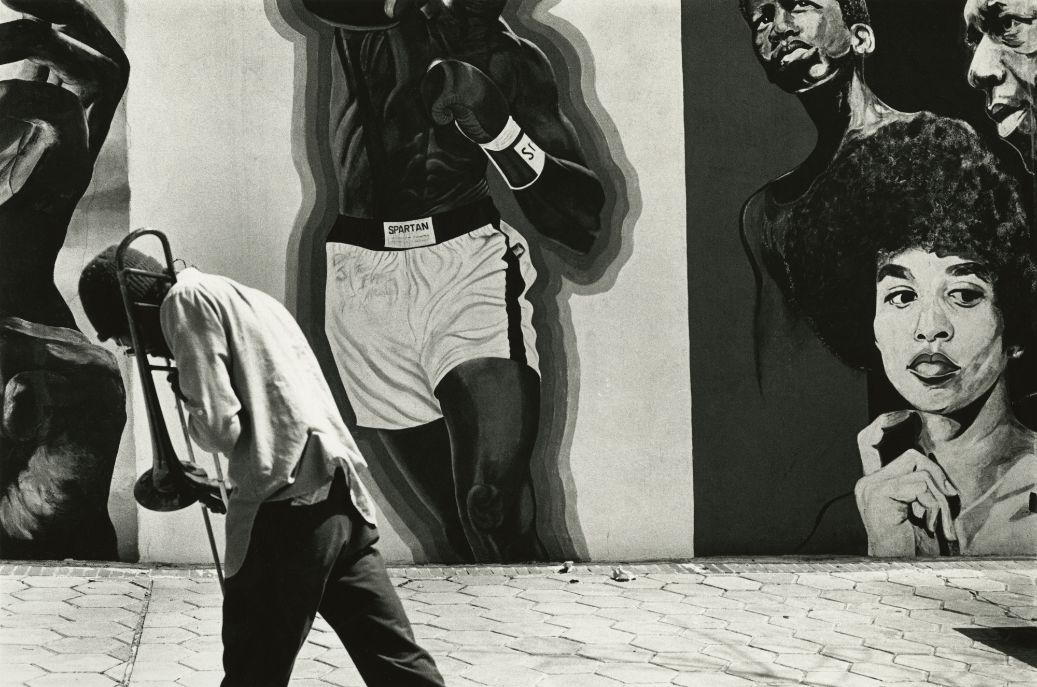
In the early 1960s, when African-American photographers were keenly aware of their isolation in a field dominated by white men, two collectives held a joint meeting. The result of that encounter was a decision to merge and form a more robust group they called Kamoinge, which in Kenya’s Kikuyu language means a group of people acting together.
“We saw ourselves as a group who were trying to nurture each other,” Louis Draper, a founding member of the Kamoinge Workshop who died in 2002, once wrote. “We had no outlets. The magazines wouldn’t support our work. So we wanted to encourage each other … to give each other feedback. We tried to be a force, especially for younger people.”
To commemorate its 50th anniversary, the workshop has published “Timeless: Photographs by Kamoinge” (Schiffer), a survey of its evolving and wide-ranging work and an important contribution to the history of photography.
“We speak of our lives as only we can,” Mr. Draper wrote about the personal and individualistic perspective of Kamoinge’s African-American photographers, and the book affirms that with a multifaceted, richly textured and global view of the black experience. Today, even as media depictions of people of color continue to rely on negative stereotypes and clichés, these pictures resonate with complexity.
Founding members of the workshop included Mr. Draper, Albert Fennar, Ray Francis, Herman Howard, Earl James, James Mannas, Calvin Mercer, Herbert Randall, Larry Stewart, Shawn Walker and Calvin Wilson. Roy DeCarava, who helped shape the group and give it direction, was voted its first director.
As the group expanded and its roster changed — Mr. DeCarava left the workshop in 1965, and its first female photographer, Ming Smith, joined in 1972 — it supported a range of projects. These included exhibitions, initially at the gallery and meeting space the workshop rented in a Harlem brownstone and later at the Countee Cullen Library, the Studio Museum in Harlem, the International Center of Photography and other sites. The workshop also hosted lectures and group critiques and published portfolios, which it distributed to museums.
The book includes a brooding and elegant portrait of the writer and activist Amiri Baraka; a silhouette of bass players in a Lower East Side club; an austere bird’s-eye view of a city park in winter; a photo of a child in Bedford-Stuyvesant learning how to tie a necktie; a haunting image of a sheet hanging on a clothesline, evoking Ku Klux Klan hoods; an arid Malian landscape, camels resting in the distance; a jarring photograph of a mother holding a toddler in Louisiana, an electronic monitoring device strapped to her leg; a dapper gentleman in a white fedora, his clothes an essay in bold contrasting patterns; and a study of children playing in a Rwandan refugee camp.
“The photographs are a rich contrast to the ‘headline’ images that have circulated worldwide about black communities known only as the roughest and toughest neighborhoods to live in,” the photographer and photo-historian Deborah Willis wrote in the book. “We have seen countless images of black life across the diaspora and I consider these photographs to be a mosaic of the black experience; they expand our consciousness and challenge what we think we know about black life.”
Embracing abstraction, conceptualism, surrealism, portraiture, social documentary, performance documentation and landscape, cityscape and street photography, this work challenges the myth of a unified African-American aesthetic. Nevertheless, its interpretation has sometimes been limited by this idea: A Kamoinge portfolio published in the July 1966 issue of Camera, a leading Swiss photo magazine, was titled “Harlem” by an editor, despite its range of locations, content and viewpoints.
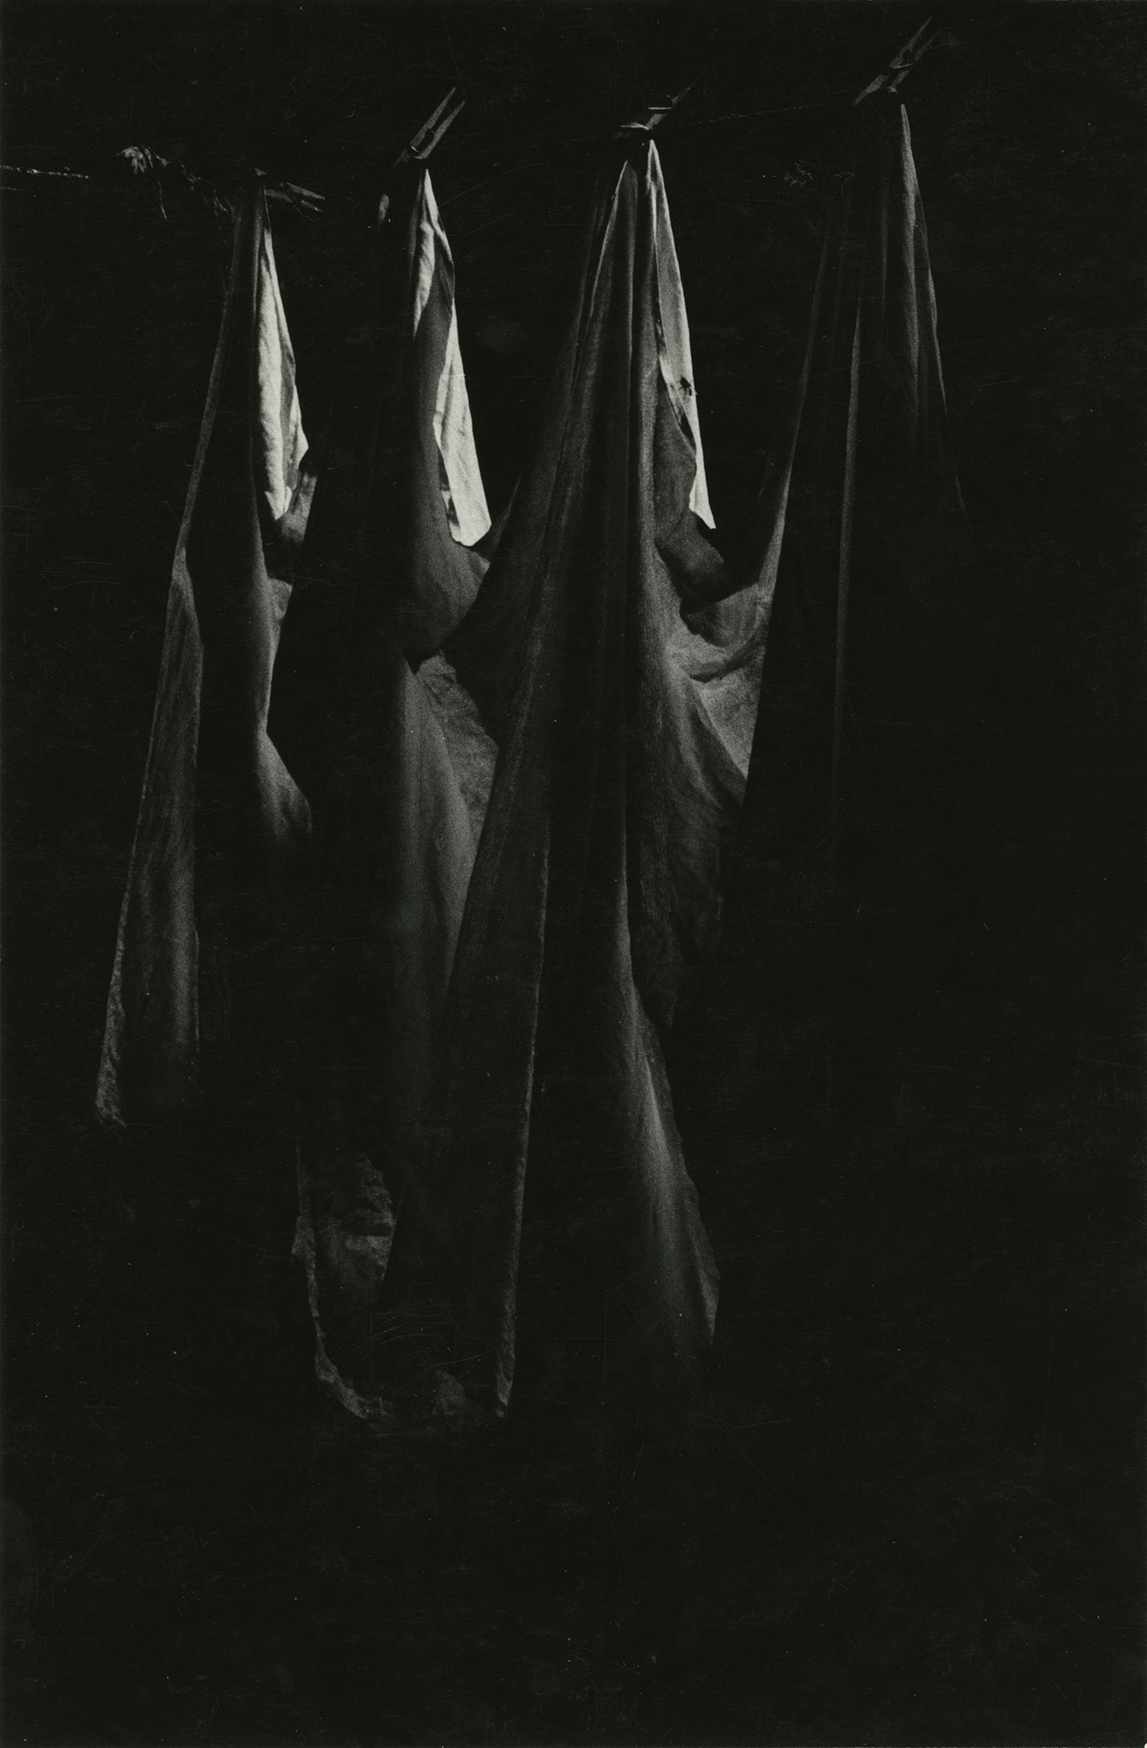
Despite this misconception, Kamoinge photographers have approached their subjects from differing emotional, political and cultural perspectives. As the art historian Erina Duganne observed in an article on the diversity of the group’s imagery, “rather than speak for African Americans as a group or act as a corrective lens, the Kamoinge members used their photographs to explore how the particularities of their individual circumstances — including their collective experience of racial difference — informed and complicated their art.”
If Kamoinge members worked together and learned from one another in order to change how global black life was represented, their photographs were also influenced by, and produced in dialogue with, eminent artists of all races. It is in this context that their work helps us to better understand not only the people and communities they engaged, but also aesthetic, cultural and social issues germane to the broader history of modern art and photography, a history from which these artists have been largely excluded.
The workshop has evolved over the last half-century: Some participants have died, including Mr. Draper and Mr. Francis. New members were welcomed. Solo and group exhibitions were mounted and articles written about the group. Members opened studios, became college teachers and took on magazine and advertising assignments. But even as the Kamoinge Workshop grew in stature, its members remained focused on their profoundly individualistic creative mission.
“Kamoinge photographers have never followed the latest trends, but nonetheless we have been influenced by what is around us,” wrote Anthony Barboza, the current workshop president. “As artists, we are moved by all that happens every day; artists are sponges that absorb the feelings of the self and the world and reflect back what we see. Within each photograph is what the artist has lived, and you see the individual’s truth that has been breathed into the art form.”
A companion exhibition, “Kamoinge: Timeless,” is on view at the Wilmer Jennings Gallery in New York through Feb. 20.
Maurice Berger is a research professor and the chief curator at the Center for Art Design and Visual Culture at the University of Maryland, Baltimore County, and a consulting curator at the Jewish Museum in New York.

