
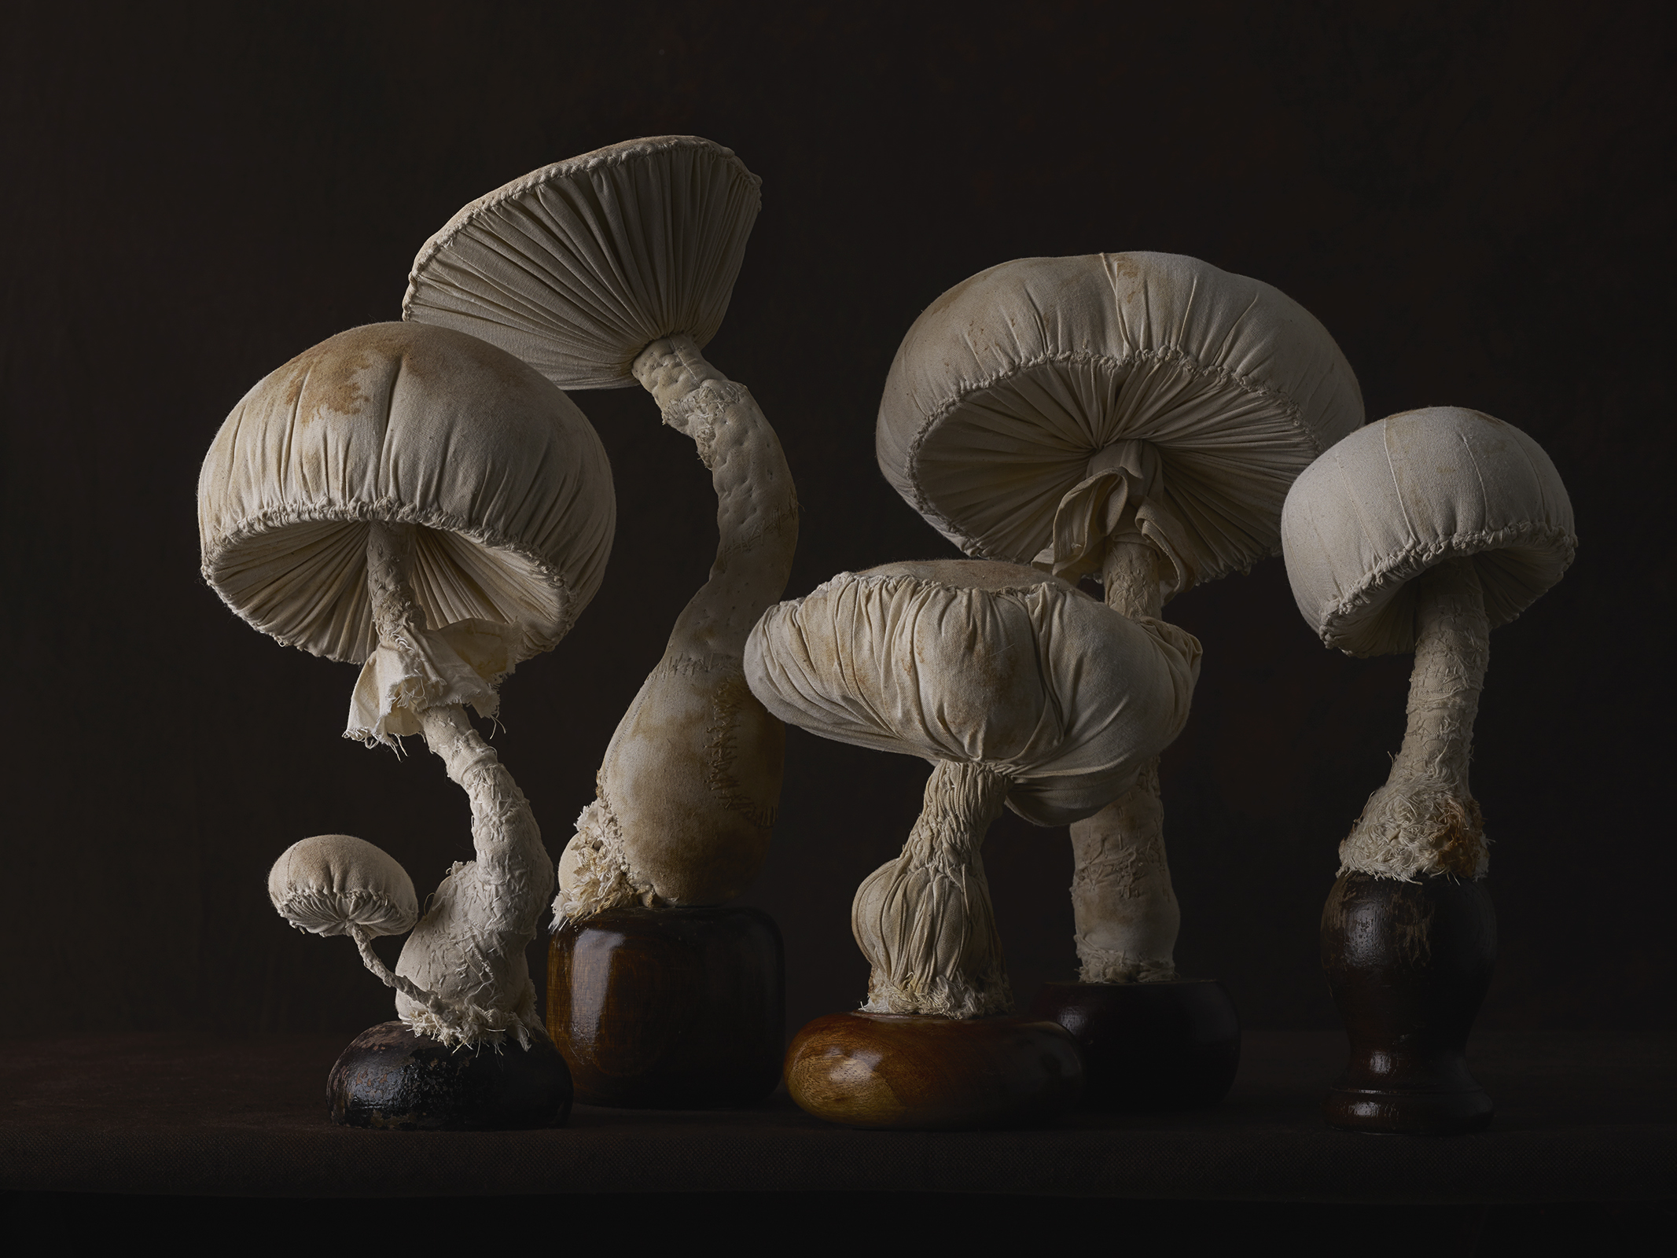
The World’s Most Elegant Toadstools
December 3, 2015

Mushrooms generally aren’t very beautiful — but at the hands of the textile artist Mister Finch, they become something elegant, and otherworldly. For a new series of photographs, which will go on view next week at the Steven Kasher Gallery in New York, the photographer Patricia Heal has teamed up with the curator Michael Reynolds to create stunning images of Finch’s toadstools. At first glance, the carefully composed arrangements look like images of living mushrooms. But upon a closer look, the viewer realizes that they’re old textiles, expertly arranged and set against dark velvet backgrounds. An everyday object, infused with a little fairytale magic.

